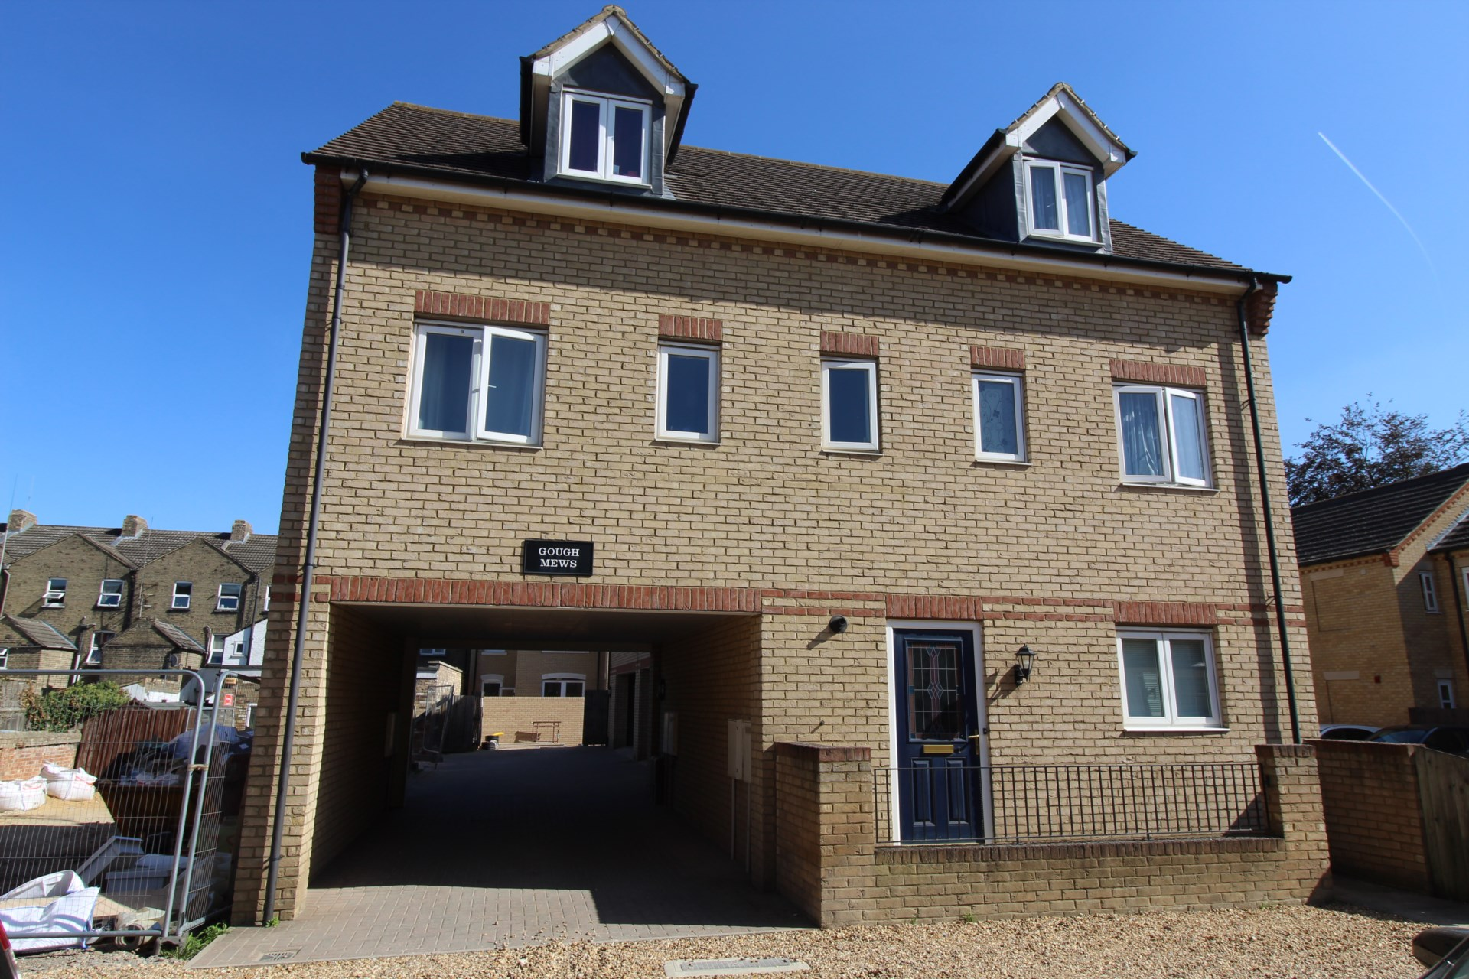



Flat 2 Gough Mews, West Street, St Neots, PE19 1AH

Asking Price

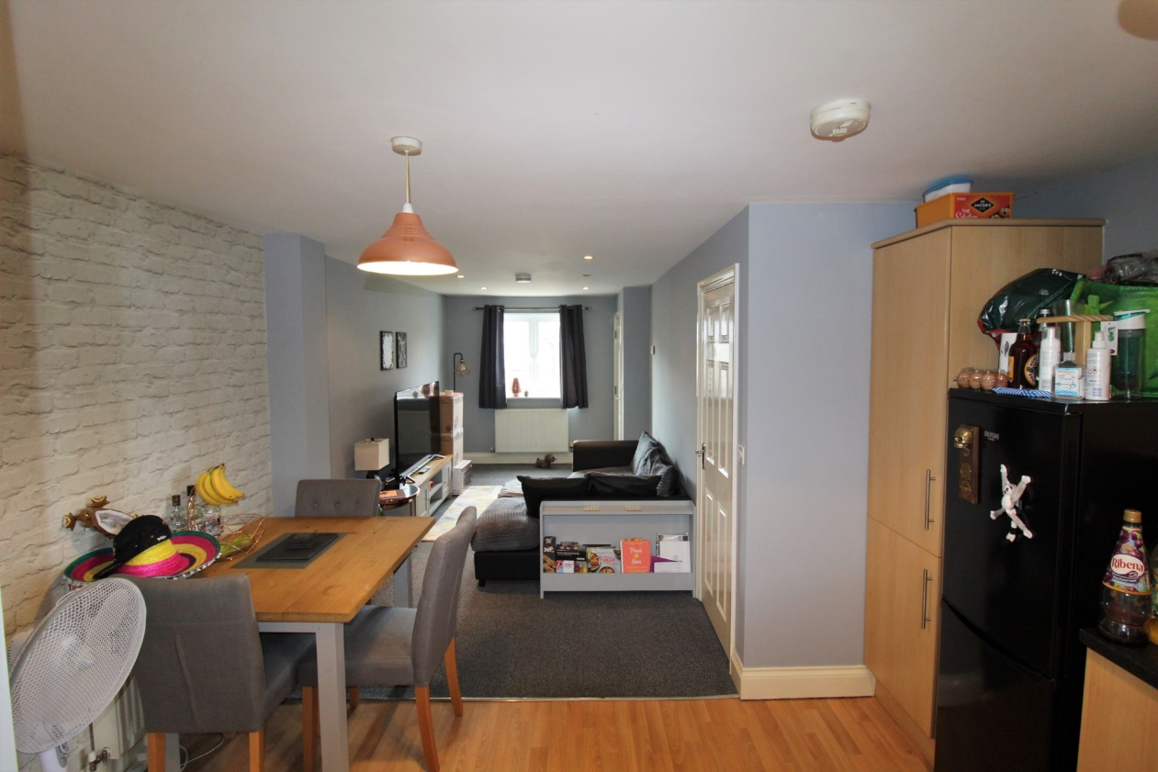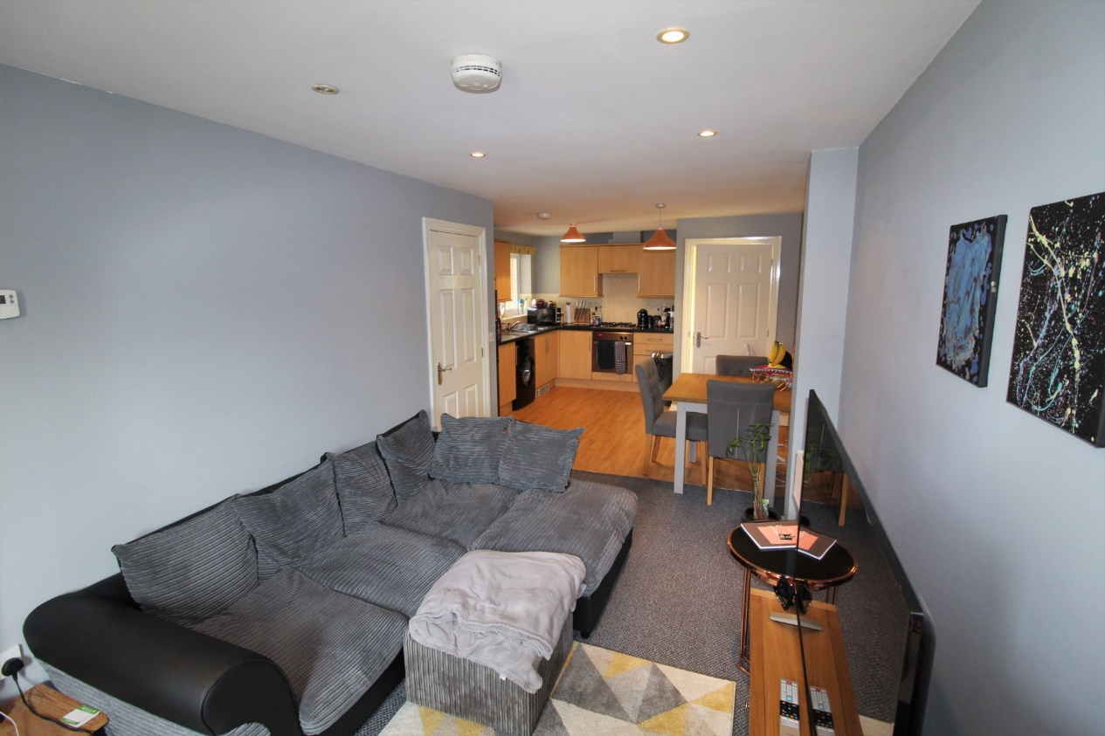

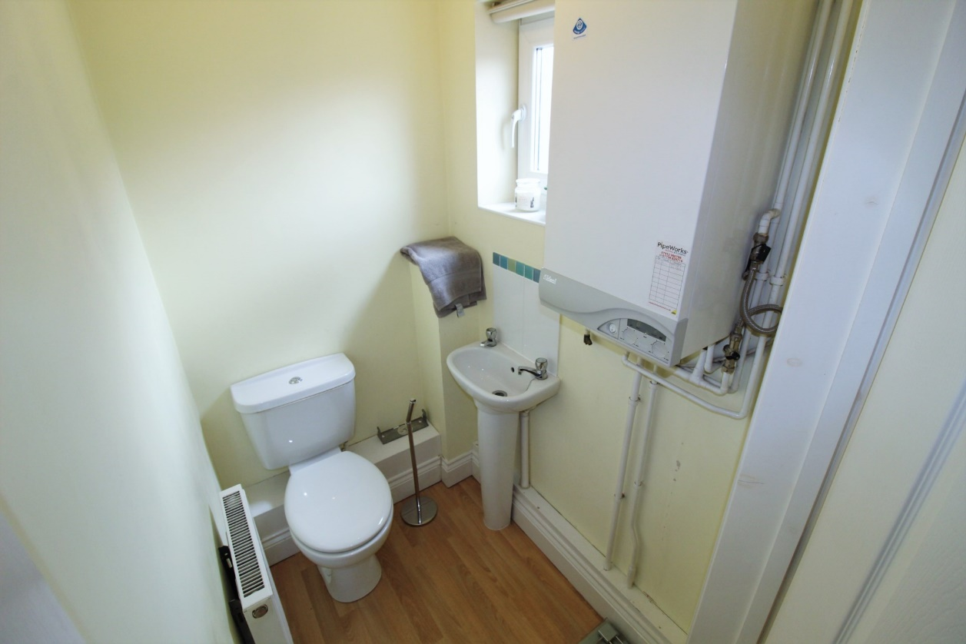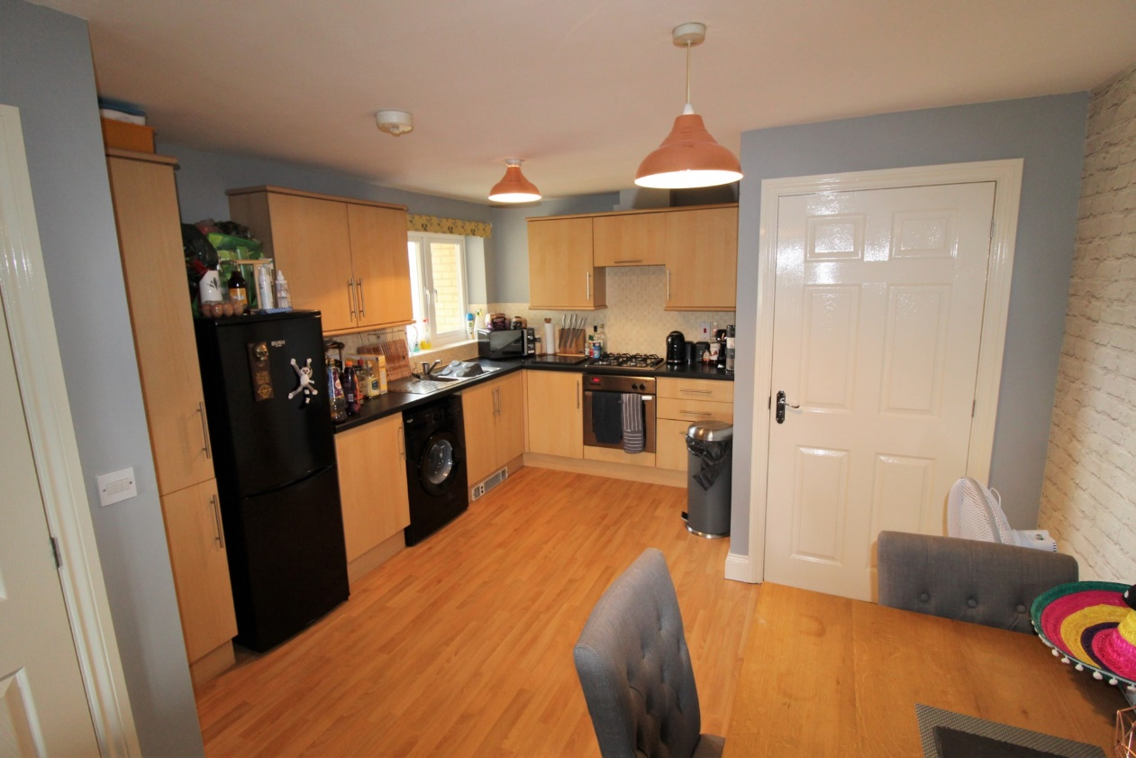

£894.23

Annafield Estates are pleased to offer this Immaculately Presented 1st Floor Maisonette for rent. Located in the heart of St Neots, Walking distance to the Market Square, The train station and both Riverside Park and Priory Park. This 2 Double Bedroom property with accommodation over two floors. This property benefits by having an entrance lobby, Living room and an open plan kitchen diner. The modern kitchen has beech wooden effect units with built in electric oven and gas hob. The property also benefits from having a 1st floor WC. Upstairs there are two double bedrooms and a reasonable sized modem white bathroom suite consisting of bath with shower facilities over, sink and toilet. The property is fully double glazed and boasts a gas central heating system. Outside there is private area leading to a carport providing an allocated single parking space. The property is available April 2021.

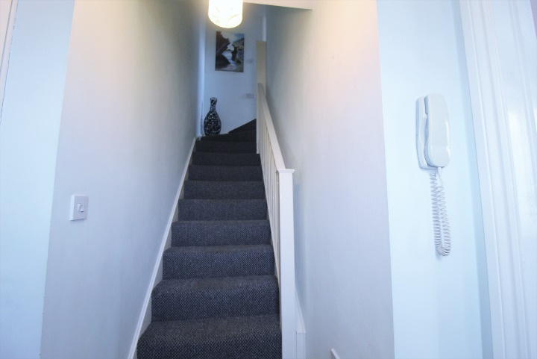



**Viewing by appointment only 01480 587678**

[enquiries@annafieldestates.co.uk](mailto:enquiries@annafieldestates.co.uk)

32 High Street, Buckden, St.Neots, PE19 5XA

**www.annafieldestates.co.uk**